Project Title

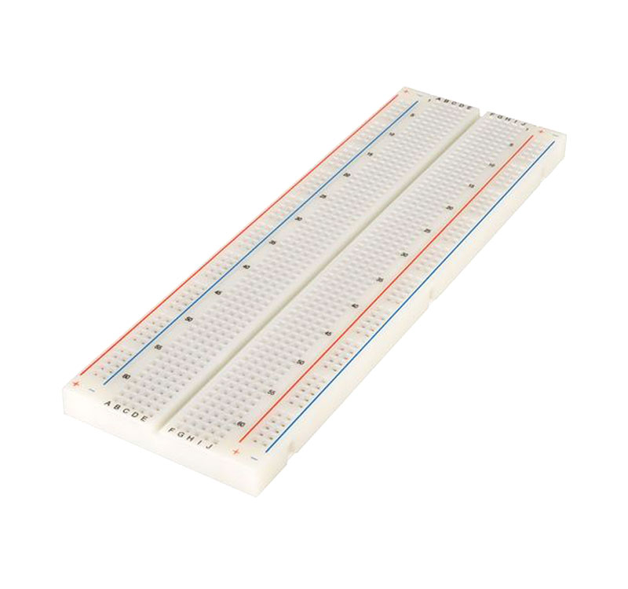

Texas Tech University

Fall 2022

Description

Here is a basic description of the project and what it does. 2-3 sentences.

Table of Contents

List of Figures 3

List of Tables 4

1. Introduction 5

2. Audience 5

3. General Format 6

4. Organization 6

4.1 Title Page 7

4.2 Abstract 7

4.3 Table Of Contents 7

4.4 Introduction 8

4.5 Body 8

4.6 Conclusion 9

4.7 References 10

4.8 Appendices 10

5. Tables and Figures 11

6. Equations 14

7. Plagiarism and Intellectual Honesty 15

8. Evaluation 15

9. Uploading Papers 16

References 17

Appendix A Reference Forms 18

Appendix B Written Lab Report Evaluation Form 20

# List of Figures

Figure 1: Example Oscilloscope Trace. 12

Figure 2: Example Chart. 13

Figure 3: Example of a Figure taken from another source [2]. 13

Figure 4: Example drawing generated by the *Word* drawing tool. 14

Figure 5: Example Schematic. 14

# List of Tables

Table I: Example Table. 11

# 1. Introduction

A basic introduction to the project.

# 2. Schematics(if required)

Schematics and explanations.

# 3. Hardware setup(if required)

A hardware setup guide

# 4. Required software

# 5. Code

A basic rundown of the code if there is anything complex.

# 6. How to use

How to use/how to setup code and execute code

# 7. Images and Video

Video Link:

Embedded Images

Table I: Example Table.

|  |  |
| --- | --- |
| Speed Step | Data Bits (3-0) |
| Stop | 0000 |
| EStop | 0001 |
| Step 1 | 0010 |
| Step 2 | 0011 |
| Step 3 | 0100 |
| Step 4 | 0101 |
| Step 5 | 0110 |
| Step 6 | 0111 |
| Step 7 | 1000 |
| Step 8 | 1001 |
| Step 9 | 1010 |
| Step 10 | 1011 |
| Step 11 | 1100 |
| Step 12 | 1101 |
| Step 13 | 1110 |
| Step 14 | 1111 |

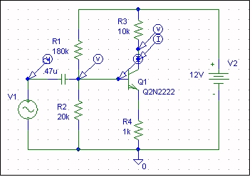

Figure 5: Example Schematic.

# References

1. Department of Electrical and Computer Engineering, Texas Tech University. “Electrical Engineering Written Report Formats,” <http://129.118.19.6/lab/REPORTS.html>, September 25, 2001.

2. Brandt, Michael. “The DCC – MB Homepage”, 1996, <http://web.syr.edu/~mobrandt/dcc-mb/dccmbhom.htm>, September 26, 2001.

# 